How to save a new Macro Free workbook

1. With the input file open, click File -> Save As

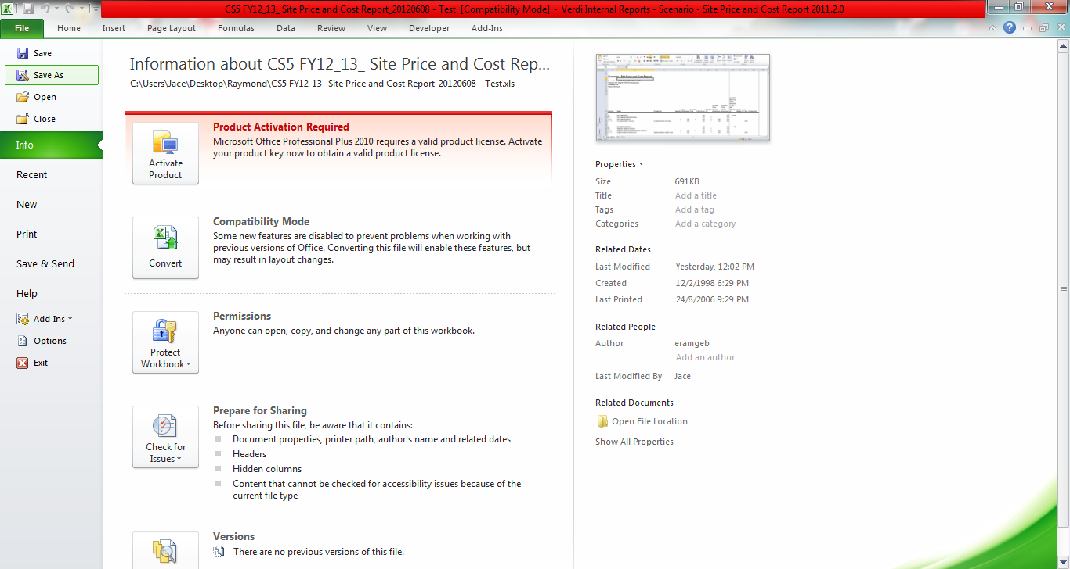

2. A small window will pop up. In the "Save as type" field, select Excel Workbook, then click “Save”

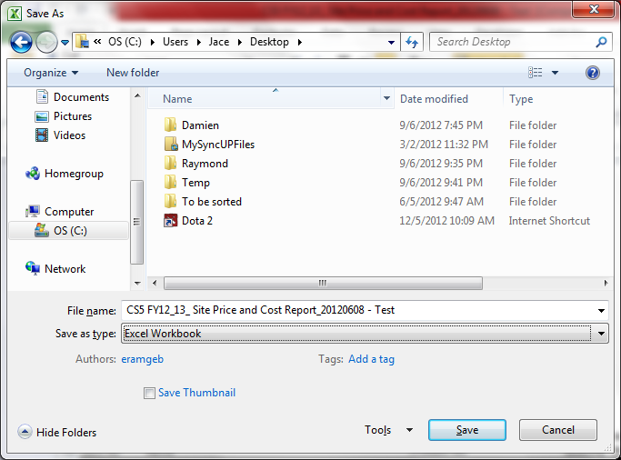

3. Another window will pop up, saying that the VB project feature can't be saved in a macro-free workbook. Ignore this, and just click Yes to continue saving as a macro-free workbook

